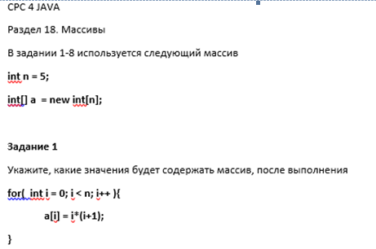

|  |  |  |  |  |
| --- | --- | --- | --- | --- |
| 0 | 2 | 6 | 12 | 20 |

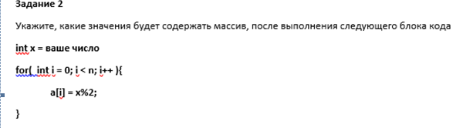

Int =9;

|  |  |  |  |  |
| --- | --- | --- | --- | --- |
| 1 | 1 | 1 | 1 | 1 |

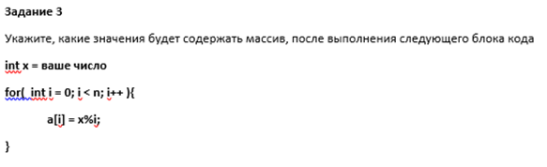

Ошибка на ноль делить нельзя

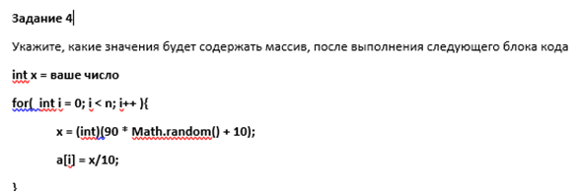

Int x = 9;

|  |  |  |  |  |
| --- | --- | --- | --- | --- |
| 4 | 3 | 1 | 3 | 3 |

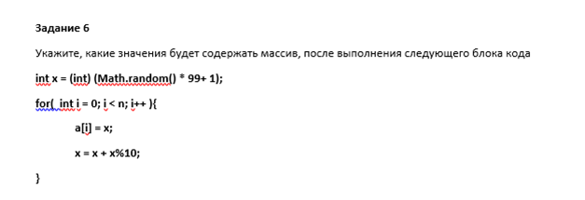

|  |  |  |  |  |
| --- | --- | --- | --- | --- |
| 3 | 6 | 12 | 14 | 18 |

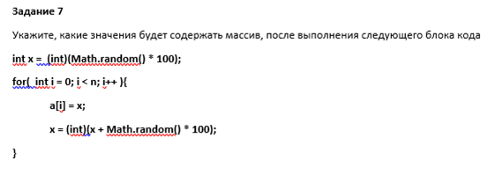

|  |  |  |  |  |
| --- | --- | --- | --- | --- |
| 66 | 76 | 130 | 204 | 277 |

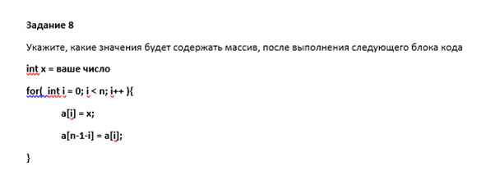

Int x = 9;

|  |  |  |  |  |
| --- | --- | --- | --- | --- |
| 9 | 9 | 9 | 9 | 9 |